ROLE DESCRIPTION

West Cumbria Area Lead

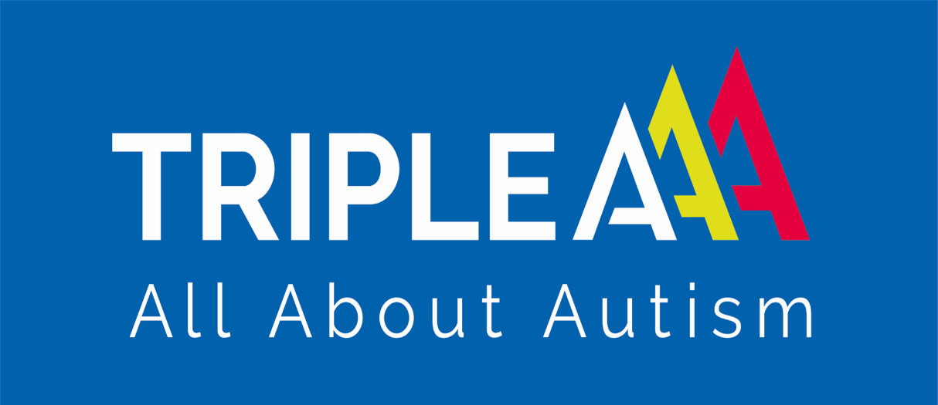

www.tripleaproject.org.uk

West Cumbria Area Manager: TRIPLE A
Reports to | Chief Executive Officer, trustees
Works with | CEO, Operations manager, Community services manager, Triple A Staff, Navigator mentors, Work Coaches, Youth Worker Professionals, Community, service users and their families.
Hourly rate | £30,000 pa pro-rata
Holiday entitlement | 5.6 weeks pro-rata
Hours | 22.5 hours weekly
Location | Based in Whitehaven with occasional travel to Penrith for in person training and events
Contract | Employed by Triple A with flexible agreed working hours, which may be subject to change as service needs alter.
Closing date | Friday 21st of August
Applications | Email full CV and covering letter explaining why you want the job and would be suited to it. Applications will not be considered without a covering letter. Contact is reasonable adjustments are needed.

Job description:

We are looking for a passionate, motivated and adaptable person, with strong understanding of autism and neurodivergence and with excellent local knowledge and connections, to spearhead development of Triple A’s new satellite office in Whitehaven. You will have supervisory responsibility for a small team of West Cumbria based service delivery staff and will work in partnership with them and the wider Triple A team to raise awareness of Triple A’s services in the local area, improve services, track outcomes and develop effective collaborative relationships with other organisations serving the local community. You will be based in Whitehaven with Responsibility for the smooth running and administration of Triple A service delivery across West Cumbria, with support from the central team. This is essentially a project management role with some supervisory responsibility, offered as a one-year initial contract, with a view to expanding the role or extending the contract duration subject to funding.

About our organisation: Triple A (All About Autism) is a small, Penrith based, charity working across Cumbria, supporting and connecting autistic adults. We operate a diverse service portfolio including the Navigator one-to-one Mentoring Programme, social groups, post-diagnosis support, Inclusion @ Work/ Connect to Work support, and Autism Awareness training delivery. We are currently expanding our youth service offer for young people aged 14 to 18 years old.

Applications: Please send CV and covering letter explaining why you would be suited to the job to admin@tripleaproject.org.uk by Friday 21st of August. To comply with safer recruitment practices any employment gaps must be clearly accounted for in your CV - this is to safeguard our vulnerable service users only, so please don't let that put you off applying if you took time off for health or family reasons or similar, we'd love to hear from you!

Job Summary:

Responsibility (with central support) for administrative management and oversight of Triple A services within the West Coast of Cumbria area including direct supervision of Navigator mentors and group facilitators. Reporting to chief executive officer and Operations manager.
You will provide monthly one-to-one staff supervision and provide on-call phone cover on a rota with the central management team (usually during working hours with occasional cover for evening groups and events).
You will be responsible for raising the profile of Triple A in the local area through public engagement, service development, networking and collaboration.
As this is a part-time role some of your duties will be shared as needed (most of the Triple A team also work part-time).
As is the nature of a small but growing charity our services and projects are often required to change or evolve in response to new opportunities or changes in the social or political landscape in which we operate: being comfortable with this and helping procedures, systems and staff adapt to changes smoothly will be an essential part of your role.

The Role and main duties:

- Implementation and administration of service processes including referrals, staffing and case management
- Carrying out monthly staff supervisions
- Development of high-quality volunteer opportunities
- Supervising and supporting volunteers
- Collaborative involvement with pilot and research projects
- Liaising with other services and support staff and attending multi-agency panels
- Triaging new referrals: contacting and meeting with new Navigation referrals and ascertaining their needs, goals and appropriateness for Navigation
- Collaboratively allocating and monitoring staff caseloads with the Operations manager
- Arranging alternative cover in the event of staff sickness or absence
- Providing on-call phone cover for Navigation and facilitation staff on a rota
- Supporting service delivery staff to track and monitor outcomes and goals
- Providing occasional out of hours on-call support for social groups and Discover Your Autism sessions, by arrangement
- Ensuring consistent and accurate reporting of outcome data and collating this in a timely and orderly fashion and to assist with board/contract/grant reporting where needed
- Collaborating with the central management team to prepare and deliver regular staff meetings and training
- Collaborating with the senior management team, staff and trustees to review and update policy
- Ensuring all mandatory staff training and certification is recorded and up to date in collaboration with the Community Services manager
- Ensuring group activities are well-planned by facilitators with appropriate risk assessments in place in collaboration with the community services manager
- Responding appropriately to incidents and safeguarding concerns ensuring they are properly recorded and reported to the appropriate authority in a timely fashion
- Ensuring complaints or disputes are handled sensitively and professionally and are confidentially recorded and filed
- Meeting with the central management team regularly, via teams, to update them with key service and case information and keeping them informed of any significant opportunities, developments or incidents
- Supporting and advising staff around maintenance of professional boundaries and client confidentiality
- Project development and innovation

Person specification
Note: We know not every strong candidate will have all of the “ideal” attributes listed below, we will happily provide additional support and training for the right candidate.

The ideal candidate will:

- Be passionate about stakeholder engagement
- Be passionate about lived experience-led service design, development and delivery
- Have a very strong and up to date understanding of autism
- Have a strong connection with and understanding of understanding of communities based in Copeland and/or West Cumbria as a whole.
- Have experience working with autistic people and/or lived experience of autism
- Have strong administrative skills and be well organised
- Have direct project management experience or equivalent relevant experience
- Be proactive in building up positive professional working relationships with local businesses and organisations
- Be comfortable taking collaborative responsibility for development and delivery of a variety of different projects depending upon the charity’s need
- Enjoy developing, implementing and updating systems, procedures and processes
- Enjoy innovative and creative thinking
- Be comfortable with a self-directed work schedule
- Work well both independently and as part of a team
- Be able to work well with neurodivergent colleagues (Triple A’s team and leadership are majority neurodivergent, primarily autistic and/or ADHD)
- Be familiar with risk management principles and procedures
- Have a solid understanding of safeguarding principles and procedures, and be willing to undertake ongoing safeguarding training
- Have management/project management experience within the health and social sector
- Be able to work comfortably with Excel, Outlook, Teams and Word
- Be able to keep a cool head in a crisis
- Be open minded and accepting of others
- Be flexible and adaptable to organisational growth, diversification and change
- Be able to adapt your management style to the needs of individual staff members
- Be passionate about developing and maintaining neuroaffirming working practices
- Autistic applicants particularly welcomed

